**MEHRAN UNIVERSITY OF ENGINEERING AND TECHNOLOGY,**

**JAMSHORO**

**Applied Physics**

**Assignment 02**

**Submitted By: 20ES003**

**20ES007**

**20ES009**

**20ES011**

**20ES013**

**Submitted To:**

**Dr. Abdul Hakim Memon**

**Assistant Professor**

**Electrical Engineering**

**MUET Jamshoro**

**Department:**

**Electronic Engineering**

**20-Batch**

# Q no: 1

# Discuss in detail the design procedure of modern Regulated Power Supply

# How to Design a Regulated Power Supply

## Abstract

The main objective of this work is to design and develop a stabilized fixed and variable power supply unit (single and dual power supply) with a voltage of 5 V fixed DC, 0.25V – 15.0V variable DC, +12 V & -12V dual power supply and current range of 0 – 1Amps (45W) with a very low output impedance of 0.010ohms with short circuit protection. We also find the load and line regulation characteristics of a constructed power supply so as to determine its stability by comparing it with standard power supply unit. Testing of constructed power supply unit to power loads (Rheostat) of 120ohms 1A and 10ohms 0.5A.The major components used include step down transformers (Input 230V AC, Output 12V AC, Output 24V AC), 1N4007 Diodes, Capacitors, ICs (7805 IC, 7812 IC, 7912 IC and LM317 IC,) and fixed & Variable resistors i.e. potentiometer, transistors. The developed power supply is tested for its functionality and the measured values are compared with nominal designed values. The designed power supply is much useful in measurements laboratory works and general applications requiring power supply.

KEYWORDS:

Power Supply, Transformers, Transistors, Diodes, Capacitors, Variable resistors, LED, PSU

## 1: Introduction:

Regulated DC power supply provides accurate DC voltage, which are derived from AC mains. The Power supply unit (PSU) is a device that supplies electrical power to a device or group of devices (Showed, et. al., 2011). These DC supplies are cheaper in nature than the DC sources from battery. Such supplies provide constant voltage irrespective of load variations for which they are designed. DC power supplies are extensively used in various electronics laboratories and industries to supply DC voltage to the electronic circuits. There are two type of power supply.

1. **Preset Power supplies (single or dual supply type).**

These power supplies are generally customs made and preset for fixed voltages like 5V/12V/15 Volts etc. These supply units are normally mounted on integrated into the electronic equipment.

1. **Variable power supplies (Single or Dual supply type)**

Variable power supply is generally available in the range of 0 to 15 volts in 0.5 to 1 amps capacities. The regulated power supply is used to supply the power for linear integrated circuits, sensitive circuits, analog and digital circuits, TTL. The DC voltage produced by a power supply is used to operate electronic circuits, such as television receivers, stereo systems, VCRs, CD players and laboratory equipment. A dual-polarity power supply is used for FM receiver and linear integrated circuits like OPAMP circuits. Organization of the paper: section II deals with the literature survey on regulated power supply. Section III describes the Design of PSU with short circuit protection. Section IV explains the Implementation methodology. Section V gives the brief idea of the results and discussion, Section VI is for the conclusion and future scope.

## 2: Literature Review:

In paper (Shown, et. al., 2011) the author has designed and developed simple but efficient digitally controlled regulated power supply of a variable voltage ranging from 0v to 15v with a maximum output current of 5A. The approach employed here is generally an embedded system, designed around an intelligent microcontroller which is provided with a digitized reference voltage to control the input and the output liquid crystal display for the provision of greater precision, stability and accurate results. In paper (Adelakun, et. al., 2014) the design of the uninterrupted power supply (UPS) for personal computer (PC) for personal computer desktop workstations is carried out. Apart from its original functionality as a backup source of power, this design incorporates the unit within the system unit casing, thereby reducing the number of system components available. From the literature survey, the design and development of the power supply for the multiple power source is already developed, the only limitation with the existing work is to provide short circuit protection for the developed regulated power supply unit. This motivated us to design and develop the multiple source regulated DC power supply unit with short circuit protection.

## 3: Methodology

## DESIGN OF PSU WITH SHORT CIRCUIT PROTECTION

The major components of the regulated dc power supply unit [PSU] are voltage drop at step down transformer or X- rated capacitor, rectification, smoothing with capacitor filter, control and voltage regulation. This applies to all the regulated power supplies that are designed in this work. The detail block diagram of developed power supply unit with and without transformer is as shown in figure 1and figure 2 respectively. The basic and integral components of the block diagram in Fig 1 and Fig 2.

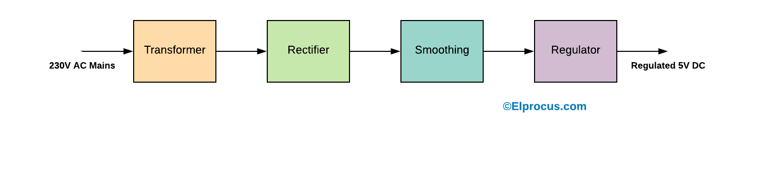

Figure 1: General Block diagram of Transformer based regulated Power Supply Unit

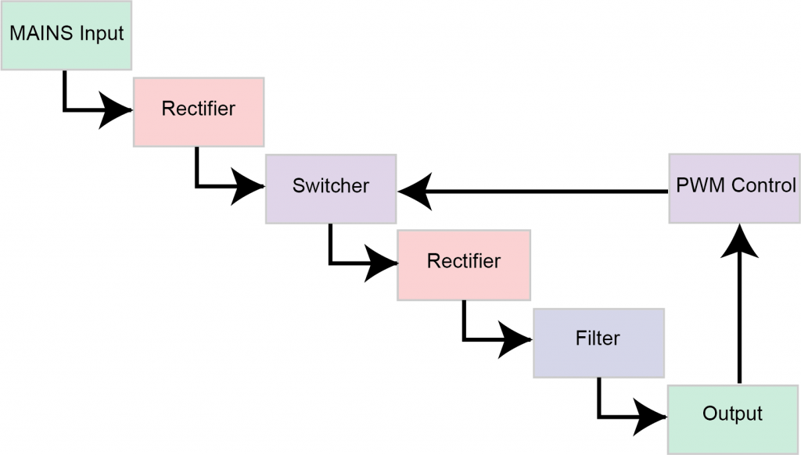

Figure 2: General Block diagram of Transformer less regulated Power Supply Unit

## DESIGN PARAMETERS FOR PSU

The following are the design parameters which are required to design the PSU.

### Line regulation

It is the capability to maintain a constant output voltage level on the output channel of a power supply, despite change to the input voltage level.

Line regulation = Change in output/ Change in input voltage. ………………….(1)

### Load regulation

It is the capability to maintain constant voltage level on the output channel of a power supply despite change in the supplies load.

% Load regulation = [Vmin load – Vmax load] /Vno load * 100 ………………….(2)

Where,

Vmax load is voltage at maximum load

Vmin load is voltage at minimum load

Vno load is the voltage at the typical specified load

### Efficiency

It is the ratio of the DC output power to the AC input power supplied to the rectifier.

% η= [Pdc / Pi] * 100………………….(3)

Where,

Pdc = DC output power of rectifier.

Pi = AC input power of rectifier.

### Ripple factor

It is the ratio of the rms value of AC component present in the rectifier output to the DC component of the rectifier output.

Ripple factor (Rf) = Vac / Vdc ………………….(4)

Where,

Vac is the rms value of AC component present in the rectified output

Vdc is the rms value of DC component of the rectifier.

### Dc Load current

Dc load current is the current flow resulting from resistive elements of the load on an output. Idc = Im / π ………………….(5)

## IMPLEMENTATION

There are many types of power supply. Most are designed to convert high voltage AC mains electricity to a suitable low voltage supply for electronic circuits and other devices. A power supply can be broken down into a series of blocks, and each of which performs a particular. The detail block diagram for the Regulated DC power supply unit with short circuit protection is as shown in Fig 3.

## THE DETAIL BLOCKS OF THE PSU

* Input Connection/ Power supply:

AC power supply of 230 V AC and 50Hz is given to the step-down transformer.

* The Transformer:

The centre-tap transformer initially takes the input supply from AC mains voltage of 230V and steps it down to a lower voltage level of 12V (12V-0-12V). However, after configuring to the circuit the desired voltage range is obtained at the output.

Turns ratio = Vp/Vs = Np/ Ns ………. (6)

Where:

VP = Primary (input) voltage,

Np = Number of turns on the primary coil,

Vs = Secondary (output) voltage

Ns= Number of turns on the primary coil.

To produce a desired output voltage of 5 Vdc, +12V & - 12V and 0- 15 V variable, a turn ratio of 10:1 transformer is chosen, thus. 230/ Vs= 10/ 1

Vs= 23V ………………….(7)

* X-rated AC capacitor:

For the transformer less based power supply, X-rated capacitors are used.

Xc = 1/ 2πfC ………………….(8)

From the formula above, if an X-rated capacitor of 2.2uF is used as, the reactance

f = 50Hz, C = 2.2uF

Then, XC = 1.44x 10^3

* The Rectifier:

The AC voltage from the transformer is rectified using Bridge rectifier to give equal positive and negative voltages. The output is DC in a sense that it does not change polarity, but it has periodic variations in voltage about a steady value called ripples. The ripple content in the output is eliminated to get the pure DC voltage. (Berkowitz, et. at., 2003,Hammed, et. al.,2008).

* The Smoothing Circuit:

The ripples are eliminated or smoothened using a shunt capacitor which is in the form of a. low-pass filter, the proper value of capacitor is chosen so that the ripple contenting the output voltage is reduced to a low level (Adelakun, et. al., 2014, Hammed, et. al., 2008).

* Output Connection/The Voltage Regulator:

The voltage regulator is used to obtain the regulated output DC voltage which is fixed DC and Variable Dc voltage. This is the stage that delivers a stabilized DC voltage to the output as set by the control unit (Hammed, et. al., 2008). The regulator circuit provides a fixed voltage for stable calibrated DC output voltages. Usually, zener diodes and transistors are used for voltage regulation purposes (Hammed, et. al., 2008)

The Fig 4. Give the details of the Voltage regulator IC like 7805, 7812, 7912, and Lm 317 and its pin configuration.

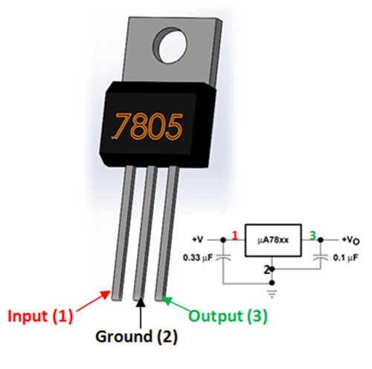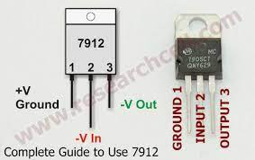

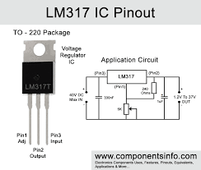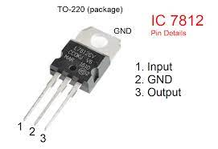

Figure 4: Shows the regulator IC and its pin configuration

## Simulation and Implementation:

The circuit is simulated in microcap before the actual implementation of the circuit on PCB, after drawing the circuit diagram using circuit simulator, the circuits converted to a PCB format and etched. The power supply unit is then constructed using circuit.

## 4: RESULTS AND DISCUSSION

The developed power supply PSU is tested and the output of each section is measured. The summary of the results are hereby discussed as follows.

### Testing and Measurement

Tests were conducted on the developed power supply unit. These include short circuit test and earthing test. The output measurement was done using digital multimeter. In each segment, measurement of the output was made ten times and the average of the measured values was obtained.

### Short Circuit Test

Short circuit test conducted on the four sections of the power supply showed that the tripping circuit worked efficiently by tripping on the LED in each of the section specially designed to show short circuit.

## 5: CONCLUSIONS AND FUTURE SCOPE

Power supply is used in most of the domestic and the laboratory equipment in order to power the smaller system or the devices. The developed multi-output power supply consists of four segmental outputs; Fixed DC 5 V output, variable DC output 0-15 V, regulated dual rectified DC output +12 V and – 12V. The variable DC output produced values ranging from 0-15V and regulated dual outputs produced ±12V and regulated DC will produce the 5V. Short circuit for the DC circuits while fuses were used to protect the AC circuit. Short circuit test and earthing test were carried out on the developed power supply unit. The output measurements showed that the developed power supply was effective and the measured values gave minimum variation from the nominal designed values. The developed system is cheap, robust and very useful for domestic application and laboratory experimental purposes.

## 6: REFERENCES

1. Shown, O., Olaniyi, O.M. and Ogunleye, O.M. (2011). Design and Development of an Intelligent Variable Power Supply Device. Pacific Journal of Science and Technology. 12(1):30-37.
2. Horowitz, P. and Hill, W. (1980). Art of Electronics. Cambridge Press: Cambridge, UK.
3. Shown, O.M. Olaniyi and O.M. Ogunleye, “Design and Development of an Intelligent Variable Power Supply Device. The Pacific Journal of Science and Technology Volume 12. Number 1. May 2011 (spring).
4. Adelakun Adebayo Oke1*, Rabiu Jamiu.Ariyo1, Egunjobi Abiodun Isiaka2 Akinnubi Rufus Timotheu3” Design and Construction of a Stabilize Variable Power Supply Unit, Innovative Systems Design and Engineering” www.iiste.org ISSN 2222- 1727 (Paper) ISSN 2222-2871 (Online) Vol.5, No.6, 2014
5. Williams, O.A. (1995). Design and Construction of a Regulated Power Supply Unit. Cambridge Press: Cambridge, UK.
6. Berkowitz, S. (2003). Powering Digital Circuits and Systems. Orbit Educational Book Publishers: Toronto, Canada.
7. Hammed, O.S. and Ademola, A.K. (2008). Design and Construction of an Emergency Rechargeable Lamp Incorporated with a Battery Overcharging Preventer Circuit. Medwell Journal of Engineering and Applied Sciences. 3(9):684-687.

**Q: no: 2**

**Explain applications of Physics in Everyday life**

* **Physics and Everyday Life**

**New Modules to Motivate Students**

The question “how to improve the interest of students to study physics” has been discussed in the author’s previous papers too. Within the framework of the project, the author prepared various new interdisciplinary projects to demonstrate how inventions in physics are used in everyday life. Now, about one year later, the author found out that students were most addressed with the modules physics and crime scene investigation physics in the kitchen, as usually with non-traditional simple experiments. The aim of this paper is to introduce the modules and discuss possible reasons of this situation.

**Keywords:**

Physics, modules, interdisciplinary, motivation

## INTRODUCTION:-

The framework educational programme for basic and high school education is based on a new education strategy, stressing the application of acquired knowledge and skills in practical life. It is important that the programme promotes the educational autonomy of schools as well as teachers’ professional responsibility for the outcomes of the educational process. The programme offers a broader range of obligatory optional subjects for the development of pupils’ interests and individual potential.

The educational area humans and nature includes a range of topics associated with the study of nature. It streams pupils to learn the tools and methods for a deeper understanding of natural phenomena and natural laws. It also gives them the necessary foundation for a better understanding and use of contemporary technology and helps them better orient themselves in everyday life. The aim is to help students to learn asking questions “how?”, “why?”, and “what will happen if?” and to seek to answer them, to explain observed phenomena, to seek out and solve cognitive or practical problems, and to use their knowledge of the laws of natural processes in order to predict or influence them.

Science educators have focused much energy on developing high-quality curricular materials that science educators will adept them. The adoption is problematic, the process is complicated and the majority of teachers are not able to use the advantages of new materials. Misunderstanding of basic phenomena leads to developing negative attitudes towards science.

The task of the research activities can be formulated: How can we change the course to promote students understanding and motivation in physics.

The questions are: how to change the course content, what instructional methods can be used, how to teach problem-solving, and how to create the relation to the outside world.

## RESEARCH FOCUS:-

It was found that there are some subjects in physics of low preference; on the other hand, some subjects are interesting for students. Low preference has subject molecular physics, waves, about molecules and atoms. On the top of interest are subjects, such as optics, astrophysics, sound, and energy. Students are interested in problems of how mobile phones works and why a steel boat can float and questions about the universe. Lack of interest were shown to information about eminent physicist living in the Czech Republic, how can be physical problems described with mathematic formulas?

It is very important that how the problem is presented by the teacher in the beginning of the lesson, motivating can be the formulation of an unexpected conclusion

As documented earlier (Jeřábek&Holubová, 2011), solving numerical tasks is the most boring activity during physics lessons. On the other hand, what most motivating are experiments that students are doing by own and using computers and the Internet in physics lessons. It was also found out that the structure of physics lessons is still mostly the same⎯the main part in most lessons is the presentation of the teacher. About 70% of lessons contain revision, and about 50% of lessons of the first part of the lesson are followed by solving tasks. More common (about 50%) are now demonstrations of the teacher and about one third of lessons contain experiments performed by students. Video and the Internet are used rarely

The aim of this research was to prepare new modules for teaching and learning physics with the focus on problems related to common life, modern technology and findings, and the own activity of students.

The list of these modules is presented as follows:

* Hands on experiments;
* Nanotechnology;
* Electronics;
* Physics experiments with data loggers;
* Physics and forensic;
* Physics in the kitchen.

All these modules were offered to secondary and high schools in Moravia. School classes had the opportunity to come and learn the theory and do some experiments in laboratories at the Department of Experimental Physics or teachers of the department were prepared to visit schools and present the modules directly in the classroom.

From all these modules, the author mostly presented physics in the kitchen, physics and forensic and hands-on experiments. In the next part of the paper, the first two modules will be shortly described.

## PHYSICS IN KITHCHEN:-

The module has two parts. In the first one, some information about devices in the kitchen is given⎯how the fridge, the microwave own, and the inductive cooker work. Some facts from the history are mentioned too.

The second part consists of experiments. As most interesting experiments were found: the CD in the microwave, a water balloon, or soap in the microwave. What found useful is the possibility to measure the speed of light in the microwave and show some properties of standing waves (See Figure 1).

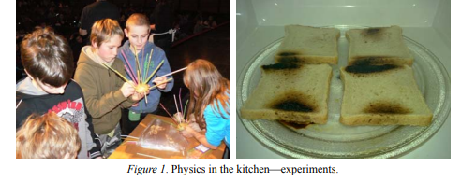

## Physics and Crime Scene Investigation:-

Forensic science includes many areas of study, such as criminalities, engineering science, and pathology and biology. The most reliable application of physics is when biomechanical analysis is used to explain injury mechanism, such as how an injury may have occurred. It is very important that the application of the free fall mechanics which originates as a result of mechanical interaction of the system “human and surrounding”. Another topic, very interesting for students, is dactyloscopy. In this topic, various experiments can be done. Students can use the dactylographic suitcase and investigate the crime scene. Students learn the fingerprint patterns⎯arches, loops, whorls, and compounds. The students learn factors that affect the quality of latent prints (amount of fat and water, temperature, humidity, and exposure to sun) (See Figure 2).

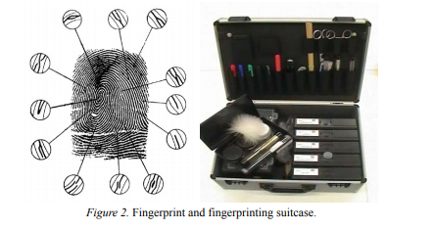

One topic among the forensic scene investigation in schools is leading in curiosity⎯the forensic entomology. The forensic entomologist estimates the postmortem interval based on the age of the insect present. This entomological-based estimation is most commonly called the “Time since Colonization”. The forensic entomologist can use a number of different techniques, including species succession, larval weight, larval length, and a more technical method known as the accumulated degree hour technique which can be very precise if the necessary data are available. The insects recovered from decomposing human remains can be a valuable tool for toxicological analysis. Toxicological analysis can be successful on insect larvae because their tissues assimilate drugs and toxins that accumulated in human tissue prior to death. This topic demonstrates interdisciplinary relations⎯physics, biology, chemistry, and geography.

## Methodology of Research:-

The outcome of this research was based on PER (physics education research), known as a field of research focused on understanding how students think about physics and how to teach physics more effectively. Over the last few decades, researchers in PER have made enormous advances in understanding how students learn physics most effectively and in developing teaching methods that apply this understanding to achieve improved student learning. That to find the answer of the research question “why the modules mentioned above” was chosen most often. This problem could be studied by using different research methods.

To get research data, the method of an interview was chosen. An interview is one of the methods of collecting data. The main characteristic of this method is that a researcher is asking questions of one person, or a group of participants. Because of the number of students, the author used a semi-structured interview. The questions were focused on topics of interest of the subject, difficulty to understand the problem (unknown terminology), interdisciplinary relations, relation to everyday life, and gender.

The interviews were recorded through the use of handwritten notes. Secondary school students (15 pupils), high school students (21 pupils), and nine teachers were interviewed. The students were representatives of their classes that took part in the presented modules.

## Results of Research:-

From all new modules, most interesting and amusing for students are hands-on experiments (see Figure 3). That module was realized at the author’s department and repeatedly at schools⎯The author was invited not only to secondary schools but also to high schools. The most important characterization of that module, as mentioned in interview, was the own activity of students⎯All experiments they did by their own. The other two modules that students found as interesting and motivating were physics in the kitchen and physics and forensic science. The most important aspect was the relation to everyday life and curiosity. From the teachers’ point of view, most interesting was the module nanotechnology. The module offers a lot of information that cannot be found in textbooks. The other interesting module was physics and forensic science. Only one high school used the module electronics.



## Conclusion:-

Main outcomes of the research can be summarized as follow. Students’ preference is the relation of physics to everyday life, when the relevance and utility of physics to their lives and careers were demonstrated. They will not study new topics but they will see how the knowledge in physics can be used in real world. In all steps of education, it is important to show the application of physics in everyday life, how staff works.

Most interesting and most important are achievements of skills useful for life⎯that is why hands-on experiments are so popular.

What can be done by the educational change⎯the curriculum, teachers, and the structure must be changed. The amount of new material presented during physics lessons is far more than a typical student can learn and understand. In lessons, there is not enough time for application, experiments, and discussion. It is necessary to teach interesting⎯this is one of the reasons, because modules presented by instructors of the Department of Experimental Physics were more interesting for students then when the topic was presented by their own teacher. It is important to understand that students are not interested in various topics, because at the actual age, they are not important for them. Students do not like mathematisation of problems⎯In the modules mentioned above, there was no mathematics (only the formulas for speed of light and the free fall of a point of mass). When the modules contain a lot of demonstrations and experiments, the relation to common life is taught, then students are interested in the topic. According to this research so as to PER, the best way to teach physics is through “interactive engagement” methods, hands-on activities with application to everyday life, and the opportunity to discussion with other students and teachers.

## References:-

1. Benecke, M. (2008).A brief survey of the history of forensic entomology.ActaBiologicaBenrodis, 14, 15-38. Retrieved from <http://benecke.com/>
2. Brewe, E. (2011). The physics teacher’s dilema.PhysTEC National Meeting, Department of Teaching and Learning and Department of Physics, Florida International University, Austin, TX.
3. Byrd, J. H. (n. d.). Insects in legal investigations.Retrieved from http://www.forensicentomology.com/index.html Holubova, R. (2011a).The work with talented high school learners. In Proceedings of the Conference DIDFYZ 2010 (p. 481), UKF Nitra, EdíciaPřírodovědec
4. Holubova, R. (2011b). Hands-on experiments. In Proceedings of the Conference Physics Teachers’ Inventions Fair 15 (pp. 55-60), Prométheus
5. Jeřábek, O., &Holubová, R. (2011).Interactive and ordinary physics tasks.Technológiavzdelávania, 18(6), 12-18 Pritchard, D. E., &Barrantes, A. (2009). What else should students learn in introductory physics? MIT Faculty Newsletter, XXII (2).

**Q no: 3**

**Moderns Physics; Problems and Solutions**

**1: Introduction:**

Modern physics either developed in the early 20th century or onward or branches greatly influenced by early 20th century physics. Notable branches of modern physics include [quantum physics](https://en.m.wikipedia.org/wiki/Quantum_physics), [special relativity](https://en.m.wikipedia.org/wiki/Special_relativity), and [general relativity](https://en.m.wikipedia.org/wiki/General_relativity).

Modern physics is often encountered when dealing with extreme conditions. Quantum mechanical effects tend to appear when dealing with "lows" (low temperatures, small distances), while relativistic effects tend to appear when dealing with "highs" (high velocities, large distances), the "middles" being classical behavior.

**2: Abstract:**

Some of the major unsolved problems in physics are theoretical, meaning that existing theories seem incapable of explaining a certain observed phenomenon or experimental result. The others are experimental, meaning that there is a difficulty in creating an experiment to test a proposed theory or investigate a phenomenon in greater detail. Can quantum mechanics and general relativity be realized as a fully consistent theory (perhaps as a quantum field theory)? [1] Is space-time fundamentally continuous or discrete? Would a consistent theory involve a force mediated by a hypothetical graviton, or be a product of a discrete structure of space-time itself (as in loop quantum gravity)? Are there deviations from the predictions of general relativity at very small or very large scales or in other extreme circumstances that flow from a quantum gravity theory? [2] In general, there are some unanswered questions or complex concepts in modern physics. These issues are divided into two categories: A: The questions that modern physics does not have answers for, and the physicists believe that it is due to the inability of theories. B - Complex concepts that seem unrealistic, but physicists have admitted they do not know the problems of modern physics. There are concepts and equations in physics (classical mechanics, relativity and quantum mechanics) that we can use to reach an understanding that is able to be experienced and by which we can review relativistic Newton's second law. Using the revised relativistic Newton's second law, we can make it easier to express complex concepts in modern physics and respond to many unanswered questions in modern physics.

Reconsidering the relativistic Newton's second law is a powerful tool that deepens our understanding of space-time and can be an important step in understanding the nature of interactions and unifying them easier.

**3: Literature review:**

Quantum mechanics and general relativity, the two pillars of 20th-century physics, have both been abundantly confirmed by experiment within very wide domains. But they are based on incompatible conceptual structures: they cannot both be exactly correct. Therefore, the central unsolved problem of theoretical physics is to find a logically consistent theory that would reduce to quantum mechanics and general relativity in their respective domains while superseding them conceptually. Superstring theory is one candidate for such a unified theory of quantum gravity.

Can [quantum mechanics](https://en.m.wikipedia.org/wiki/Quantum_mechanics) and [general relativity](https://en.m.wikipedia.org/wiki/General_relativity) be realized as a fully consistent theory (perhaps as a [quantum field theory](https://en.m.wikipedia.org/wiki/Quantum_field_theory))Unfortunately, the clash between quantum mechanics and general relativity occurs only at energies a million billion times higher than those achievable in present-day accelerators. A direct experimental test of superstring theory -- or any other theory of quantum gravity -- is thus out of the question. Nevertheless, these theories may well have experimentally testable consequences at lower energies. They may predict, for example, the masses and interactions of the various fundamental particles (quarks, leptons and so forth). We won't know whether this is the case until these theories are better understood, and it is in this direction that superstring theorists are working.

**4: Results:**

Classical mechanics and relativity (special and general) describe the acceleration is an explanation of outward of phenomena regardless the properties of sub quantum scales. It should be noted that the interaction between large objects (e.g. collision of two bodies) under the action of the quantum layer (in fact sub quantum layer) done. In sub quantum level, the amount of speed is constant, in any condition and any space, and in any interaction linear momentum changes to nonlinear momentum and vice versa. According to SQE, we are able to show there is not a zero volume with infinite density in singularity also before the Big Bang.

Thus far, physicists have been able to merge electromagnetic and the weak nuclear force into the electroweak force and work is being done to merge electroweak and quantum chromo dynamics into a QCD-electroweak interaction. Beyond grand unification, there is also speculation that it may be possible to merge gravity with the other three-gauge symmetries into a grand unified theory. But there is no way to explain how particles produce exchange particles in modern physics. A new and different way (that we have suggested) for unifying the interactions is generalizing color charge from nuclear to photon structure. This new view on color charge means that we can redefine graviton and electromagnetic energy (Sub quantum energy). This looking shows how two same charged particles repel each other in far distance and absorb each other at a very small distance.

According to the results of reconsidering relativistic Newton's second law, we can definitely say that the best way for unifying the interactions is generalizing interaction between charged particles to photon structure and vice versa. This new view on photon means that we can redefine the graviton and electromagnetic energy. Electromagnetic energy converts to matter and antimatter such as charged particles. Charged particles use gravitons and generate electromagnetic field. This way of looking at the problem shows how two same charged particles repel each other in far distance and absorb each other at a very small distance. Attention to photon structure and using new definitions for graviton, charged and exchange particles, will change our perspective on modern physics. It also provides us with a new tool to be able to overcome physics problems in a better way. This approach will show us how particles are formed.

**5: Discussion about questions and complex concepts:**

In this paper are a lot of unanswered questions and complex concepts of which the most important parts have been propounded and at the end of each question the paper of solution is given here.

1. Infinity in space-time: Assume that the observable universe would collapse due to gravity, is there any force that can counteract the gravity collapse in the universe? In other word, after the universe collapses, how and by which law (or force) will the universe expand again? A gravitational singularity or space-time singularity is a location where the quantities that are used to measure the gravitational field become infinite in a way that does not depend on the coordinate system. These quantities are the scalar invariant curvatures of space-time, which includes a measure of the density of matter. For the purposes of proving the Penrose– Hawking singularity theorems, a space-time with a singularity is defined to be one that contains geodesics that cannot be extended in a smooth manner. The end of such a geodesic is considered to be the singularity. This is a different definition, useful for proving theorems. The two most important types of space-time singularities are curvature singularities and conical singularities. Singularities can also be divided according to whether they are covered by an event horizon or not (naked singularities). According to general relativity, the initial state of the universe, at the beginning of the Big Bang, was a singularity. Both general relativity and quantum mechanics break down in describing the Big Bang. My question is, if the universe collapses, will it reach to infinite density and zero volume? Or is there a force that will counteract it? (For solution see [3]).
2. Reviewing the special relativity postulates, always raises some questions like, “Does the constant speed of light (photon energy), result from a natural accident?” or “what is the difference between the characteristics of mass and energy while the speed rate of energy is fixed; the speed of matter can change and cannot reach the speed of light?”. Meanwhile when the physical and chemical processes occur, some amount of matter is converted into energy; what happens during this process that mass with non-constant speed is converted into energy with the constant speed? (For solution see [4]).
3. According to the fundamental particle physics theories and energy issues in the production and decay of pairs of matter–antimatter are included in finding the common features between matter and energy which can be considered the constant velocity of photon as a property that can be transmitted from matter into energy and vice versa and also differences in the mass, structure of matter and its relation fields are explained by the relationship between length contraction (reduce in volume) and relativistic mass and relativistic Newton second law which show the mass variations (i.e., the infinite speed in classical mechanics is replaced by the infinite mass). Infinite mass is not observable (such as infinite velocity), how can we explain the limit of speed without infinite mass? (For solution see [4]).
4. This may probably seem an unusual question in physics however, taking it into consideration may lead us to solve some of the problems in this science. As every physicist knows, in quantum mechanics and relativity, it has been accepted that field and mass-energy are two separable items. In general relativity, gravity is replaced by space-time; therefore it is not a fundamental force. Quantum mechanics is a very good set of mathematical models that show how many elementary forces work, but it does not explain how they work. What is the main obstacle in the way of uniting the four forces and all of the elementary particles? We do not know how a charged particle produces an electric field or virtual photons in quantum mechanics. And many other unanswered questions. Maybe thinking about this seems useless or maybe it can be a step in order to find a theory of super-symmetry. Is it possible for force, energy and mass to convert to each other? If not, why? If so, how? (For solution see [5]).
5. Late nineteenth century physics was faced with a crisis in the speed of light and energy. Quantum characteristic of radiation was proposed by Max Planck and during the past century his theory was developed and it reached to the quantum mechanics and elementary particles models. Einstein proposed the speed of light by special relativity theory. In this theory the speed of light in inertial frame of reference is constant “c”, and also it is the limit rate of speed. On the other hand, visible light is a radiation which is the small part of electromagnetic spectrum. The question is: On the constancy of the speed of light: a nature law or a natural accident! (For solution see [4]).
6. The Einstein field equations or Einstein equation are not a dynamical equations that describe how matter and energy change the geometry of space-time, this curved geometry being interpreted as the gravitational field of the matter source. Einstein tried to propound geometrical structures of space by mathematical equations. So, he used non-Euclidian geometry. There are three considerable notes on Einstein’s equations;
7. Einstein Field Equations do not come from the equivalence principle directly. These equations are simply equations that are suitable for general relativity.
8. There is a physical explanation for the path of light in a gravitational field. Although explaining the frames of reference is a physical concept, there is not any explanation of how gravitational field affects photons in general relativity. Then how can we explain this phenomenon by quantum mechanics?
9. Space-time is a continuous quantity in general relativity. But the changing of photon frequency and production of energy are quantized. That gravitational blue shift (or red shift) is a special case of gravitational field that affects the photon. My question is therefore: how can we explain the gravitational blue shift according to the relationship between photon energy and its frequency? (For solution see [6]).
10. The important concept in relationship between 'mass' and energy is c, regarding the phenomena of creation and decay of electron-positron pair, why do the related photons move at constant speed, but we could change the speed of matter and antimatter? What is the unique characteristic of matter which is convertible to photons that move with constant speed c (speed of light)? The idea that object/particle could not travel at superluminal speeds, originates from the structure of matter and the mechanism of interaction between field and mass; that with presenting a postulate we could generalize the constancy of speed from energy to mass. By gravitational blue shift, the energy of photon and consequently its frequency will increase. What is the mechanism of increasing in the photon energy that causes increase in its frequency? Are there more results than before in the energy-mass equivalence equation? (For solution see [7])
11. All our theories today seem to imply that the universe should contain a tremendous concentration of energy, even in the emptiest regions of space. The gravitational effects of this so-called vacuum energy would have either quickly curled up the universe long ago or expanded it too much greater size. The Standard Model cannot help us understand this puzzle, called the cosmological constant problem [8].
12. The expansion of the universe was long believed to be slowing down because of the mutual gravitational attraction of all the matter in the universe. We now know that the expansions accelerating and that whatever causes the acceleration (dubbed “dark energy”) cannot be Standard Model physics.[8]
13. There is very good evidence that in the first fraction of a second of the big bang the universe went through a stage of extremely rapid expansion called inflation. The fields responsible for inflation cannot be Standard Model ones.[8]
14. The Standard Model cannot include gravity, because it does not have the same structure as the other three forces. In expressing these mysteries, when I say the Standard Model cannot explain a given phenomenon, I do not mean that the theory has not yet explained it but might do so one day. The Standard Model is a highly constrained theory, and it cannot ever explain the phenomena listed above.[8]
15. Richard Feynman once quipped that "Time is what happens when nothing else does." But Julian Barbour disagrees: if nothing happened, if nothing changed, then time would stop. For time is nothing but change. It is change that we perceive occurring all around us, not time. Put simply, time does not exist. [9] Efforts to understand time below the Planck scale have led to an exceedingly strange juncture in physics. The problem, in brief, is that time may not exist at the most fundamental level of physical reality. If so, then what is time? And why is it so obviously and tyrannically omnipresent in our own experience? (For solution see [10]). “The meaning of time has become terribly problematic in contemporary physics,” says Simon Saunders, “The situation is so uncomfortable that by far the best thing to do is declare oneself an agnostic.” [11] The question is, what is the physical nature of time? Which physical beings are not subject to the passage of time? (For solution see [10]).
16. In quantum electrodynamics (QED) a charged particle emits exchange force particles continuously. This process has no effect on the properties of a charged particle such as its mass and charge. How is it explainable? If a charged particle as a generator has an output known as a virtual photon, what will be its input? (For solution see [5]).
17. Zero-point energy, also called quantum vacuum zero-point energy, is the lowest possible energy that a quantum mechanical physical system may have; it is the energy of its ground state. All quantum mechanical systems undergo fluctuations even in their ground state and have associated zero-point energy, a consequence of their wave-like nature. The uncertainty principle requires every physical system to have a zero-point energy greater than the minimum of its classical potential well. This results in motion even at absolute zero. For example, liquid helium does not freeze under atmospheric pressure at any temperature because of its zero-point energy. If the zero point energy in space (vacuum) exists, how we can describe it without using the uncertainty principle? (For solution see [5]).
18. In quantum mechanics, the concept of a point particle is complicated by the Heisenberg uncertainty principle, because even an elementary particle, with no internal structure, occupies a nonzero volume. There is nevertheless a distinction between elementary particles such as electrons, photon or quarks, which have no internal structure, versus composite particles such as protons, which do have internal structure. According to the quantum mechanics that photon is an unstructured particle, how can we explain the relationship between the photon energy and frequency, and also pair production and decay? (For solution see [12]).
19. QED rests on the idea that charged particles (e.g., electrons and positrons) interact by emitting and absorbing photons, the particles of light that transmit electromagnetic forces. These photons are virtual; that is, they cannot be seen or detected in any way because their existence violates the conservation of energy and momentum. If the electromagnetic field is defined in terms of the force on a charged particle, then it is tempting to say that the field itself consists of photons which cause a force on a charged particle by being absorbed by it or simply colliding with it - as in the Photo-electric effect. The electric repulsion between two electrons could then be understood as follows: One electron emits a photon and recoils; the second electron absorbs the photon and acquires its momentum. Clearly the recoil of the first electron and the impact of the second electron with the photon drive the electrons away from each other. So much for repulsive forces. How can attraction be represented in this way? The uncertainty principle makes this possible. The attraction between an electron and a positron may be described as follows: the electron emits a photon with momentum directed away from the positron and thus recoils towards the positron. This entails a degree of definiteness in the momentum of the photon. There must be a corresponding uncertainty in its position - it could be on the other side of the positron so that it can hit it and knock it towards the electron. Is there a way to explain virtual photon (in fact interaction between charged particles) without using the uncertainly principle? (For solution see [5]).

**6: Conclusion:**

At the beginning of the 20th century, Newton’s second law was corrected considering the limit speed c and the relativistic mass. In this paper, through various arguments and investigation of some physical phenomena, it has been attempted to show the necessity of reviewing relativistic Newton’s second law. Today Physics literature faces numerous problems and questions that without considering the internal structure of the particles, they would remain unanswered. Moreover, the classical definition of energy that defines energy as the ability to do work, could not explain the interaction among the particle in high energies. The true understanding of physical entity of energy and the structure of photon, enable us to understand the structure of matter. Attention to photon structure and using new definitions for graviton, charged and exchange particles, will change our perspective on modern physics. It also provides us with a new tool to be able to overcome physics problems in a better way. This approach will show us how particles are formed and when physical symmetries are broken spontaneously. Moreover, one could explain the expansion of the universe better and more real through reviewing relativistic Newton’s second law.

**7: References:**

1. Alan Social "Don't Pull the String Yet on Superstring Theory", July 22, 1996 New York Times
2. Javari, Hussein, "Graviton and cosmology equations, before the Big Bang", General Science Journal, 2015, [Online available] <http://gsjournal.net/Science-Journals/%7B$cat_name%7D/View/6120>
3. Javari, Hussein, "Graviton and Newton's second law", General Science Journal, 2015, [Online available] <http://gsjournal.net/Science-Journals/%7B$cat_name%7D/View/6112>
4. Javari, Hussein, "Graviton and virtual photons", General Science Journal, 2015, [Online available] <http://gsjournal.net/Science-Journals/%7B$cat_name%7D/View/6119>
5. Javari, F. Forouzbakhsh, "Interactions between real and virtual space times", IJFPS, Vole 4, No 4, pp 114-121, Dec , 2014, [Online available] <http://fundamentaljournals.org/ijfps/downloads/75_IJFPS_Dec_2014_114_121.pdf>
6. H. Javari, et, at, "New Discoveries and the Necessity of Reconsidering the Perspectives on Newton's Second Law" , Journal of Nuclear and Particle Physics, 2012, [Online available] <http://article.sapub.org/10.5923.j.jnpp.20120203.02.html#Ref>
7. Kane, G., 2003, the dawn of physics beyond the standard model, Scientific American, vol. 288(6), p.68-75.
8. Barbour, Julian "The End of Time: The Next Revolution in Physics [Paperback]", 2001, ISBN10: 0195145925, Book Description
9. Javari, Hussein, "Graviton: physical time and thermodynamics", General Science Journal, 2015, [Online available] <http://gsjournal.net/Science-Journals/%7B$cat_name%7D/View/6125>
10. Folgers, Tim, "Time May Not Exist" 2007, Discover, <http://discovermagazine.com/2007/jun/in-no-time>
11. Javari, Hussein, "Graviton: Virtual photon and Quantum Chromo dynamics", General Science Journal, 2015, [Online available] http://gsjournal.net/Science-Journals/%7B$cat_name%7D/View/6136